**DUST/DIRT CLEANER**

**Report**

Submitted in partial fulfillment of the requirements for II year II semester course of

**Engineering Design Process**

**In**

**Bachelor of Technology**

Submitted by

**A. Harshith (19K41A0405)**

**A. Akshaya (19K1A0406)**

**B. Akash (19K41A0408)**

**N. Bhavith (19K41A0450)**

Under the Guidance of

**Mr. Alok Govil**

**Mr. Rohan Ande**



**Center for Design**

**SR University**

**Warangal Urban-506371, Telangana, India.**

**Table of Contents**

**Section Page**

**1. Introduction** 03

**2. Need Analysis**

I. Need statement 04

II. Function Structure 05

III. Constraints 05

IV. Order of Magnitude Calculations 06

V. Requirements 07

**3. Conceptual design**

3.1 Concept 1 by 405 08 - 09

3.2 Concept 2 by 406 10 - 12

3.3 Concept 3 by 408 13 - 15

3.4 Concept 4 by 450 16 - 19

3.5 Concept evaluation matrix 19

**4. Recommended concept** 20 - 21

**Appendix 1 – GANTT chart**  22

**Appendix 2** 22 – 24

**Appendix 3 – Patent search**  25

1. **INTRODUCTION**

The act of making something clean by brushing or wiping the dirt/dust from any surface is called dust/dirt cleaning.

Generally, the users of dust/dirt cleaners are home makers, janitors, municipal workers, cleaning / maintenance staff and they use them in different places like apartments, hospitals, malls, schools, colleges, offices, etc. and the different types of devices / products used by them are vacuum cleaner, broom, floor mopping cloths, laundry detergent, eraser sponge etc.

The domain we have selected is office and here are some different types of meeting rooms worth considering are large conference rooms, small meeting rooms, brainstorming rooms, video conferencing rooms, reception and greeting area, IT room, webinar and recording room etc.

The users of dust/dirt cleaners in an office are janitors or any office employee. Basically the work of a janitor is to clean and provide upkeep for spaces and buildings, performs basic repairs, maintains cleaning supplies, operates cleaning equipment.

The janitors/cleaning staff in an office uses mopping cloths, disinfecting sprays, vacuum cleaner, erase sponge etc. and the problems they overcome while cleaning are wet and slippery floors, working at height, falling objects, obstacles(like tables, chairs, desks) and many rooms to clean which is time taking process.

The major reason we selected office as our domain is, it consists of many rooms and it is necessary to clean them regularly which is a big task for cleaning staff. So we decided to innovate and design a product to clean dust/dirt that will easily make their work done in less time and which have multiple functionalities.

**2 .NEED ANALYSIS**

**I. About the target customer :**

* Majorly the targeted customer for the product we design are janitors/cleaning staff because they have the responsibility to maintain the place clean.
* The place where they use the product is in office (or it may be usable at multi places).
* The current dust/dirt cleaners can make the work done, but may not satisfy all the needs of customers. For example, mop sticks are just used to clean the floor and may not be to clean different areas in office.
* In the same way as mentioned above there are merits and demerits of every dust/dirt cleaner. So, we thought to design a product such that it is multifunctional, less cost and user friendly.

**About the need statement :**

* There are few draw backs of present dust/dirt cleaner because they may not fulfill all the needs of customer.
* In office there are many rooms, one type of dust cleaner cannot be used in multiple rooms for cleaning.
* All the dust/dirt cleaner are not user friendly.
* Few of them are costly though.

**NEED STATEMENT**

***The goal is to design a dust/dirt cleaner for office use having multiple functionality and is time and cost effective.***

This statement provides a general understanding of function of the product and the needs it hopes to address.

All the independent functions of multiple functionality with time and cost effective manner are illustrated in structure presented in the next section.

**II. Function structure :**

Dust/Dirt cleaner with multiple functionality

2nd function is to clean surfaces at height

1st function to clean plane surfaces

With more than

2 multiple functionality

With 2 multiple functionality

Above we have mentioned the each individual function structure.

* At the starting we have mentioned the need of product that is to design a dust/dirt cleaner with multiple functionalities.
* To attain/fulfill the need we can go for two functionality or more than two functionality dust/dirt cleaners.
* In the above two we have selected to design a two functionality dust/dirt cleaner.
* To be multi functional we can add one function is to clean plane surfaces and the other is to clean surfaces at height like walls, fans, ceiling etc. (instead of the above functionalities we have chance to add other with fulfilling the needs).

**III. Constraints :**

The constraints for already existing products are :

* For vacuum cleaner it is heavy to lift, runs on electricity, no reusable dustbin bags.
* For few mop cleaners the grip to handle it is uncomfortable, the cloth of mop may get stuck under obstacles.
* For a duster it is not effective to erase the impressions on white board after long time.
* The dust/dirt cleaners we buy may not fulfill all needs and are not reliable.

The constraints of the product we design are :

* It should be multi functional.
* It should be reliable.
* It should be cost effective and value for money.
* It should be user friendly.
* It should be time effective and comfortable to use.

**IV. Order of magnitude calculations :**

**a. Design :**

* The design and looks are similar to regular mop sticks.
* The below are the selected concept dimensions :

(FOR HANDLE)

Height = 5ft, Inner radius = 2cm, outer radius = 2.5cm, Inner threading height = 4cm

(FOR HEAD)

Length = 25cm and 10cm, width = 15cm, thickness = 5mm (surfaces at height)

Inner radius = 9.5cm, outer radius = 10cm, height = 2cm (floor)

Inner radius = 1.5cm, outer radius = 1.9 cm, outer threading height = 4cm

**b. Market :**

* The major customers of our product are cleaning/maintenance staff at offices.
* There are thousands of offices overall in India. They need dust/dirt cleaners to clean. So, it makes a very big market to sell the product.
* The product we design is approximately 150 rupees (includes cost of raw material, taxes, manufacturing cost).
* Compared to other products, the product we design is much lesser cost, multifunctional.
* Which makes our product more reliable to purchase compared to others.

**C. Value :**

* The product we design have multiple functionalities and is cost and time effective.
* It saves the time and effort of our customer, because it is multifunctional, so customer can use it for multiple cleaning tasks without using the other one.
* As we mentioned in function structure its functionality is to clean at plane and surfaces at height, so the customer doesn’t require multiple products to clean, they can use this single product we made for both needs with comfort.

**D. Weight and Size :**

* The size of the dust/dirt cleaner we would like to design is : Radius of the handle approx. 2 cm and length is 4 to 5 feet.
* The weight of product is approximately 500 to 700 grams (including all materials we use in designing our product). It is light weight so that user can handle it easily.

**V. Requirements:**

|  |  |
| --- | --- |
| **Category** | **Requirements** |
| **Performance** | 1. Make sure that it fulfills its basic operation that is cleaning. 2. Make sure it cleans the plane surfaces properly. 3. Make sure it cleans surfaces at height with ease. 4. Make sure it moves smoothly while cleaning. |
| **Value** | 1. It should be cost and time effective. 2. It should be user friendly. 3. The overall cost of product should not exceed more than 150 rupees. 4. Make sure over all it should be value for money product. |
| **Size** | 1. The size should be approximately 4 to 5 feet so that it clean plane and high surfaces easily. 2. To make sure the handle radius is not small and not big so it perfectly fit in hands. 3. To make sure the weight does not exceed more. To ensure that we use lightweight materials. |
| **Safety** | 1. To ensure that there are no sharp edges which can cause tear down skin. |
| **Special** | 1. To ensure that it is multi-functional, less cost and time compatible. |

**3. Conceptual Design**

**3.1 Concept 1 by 405 :**

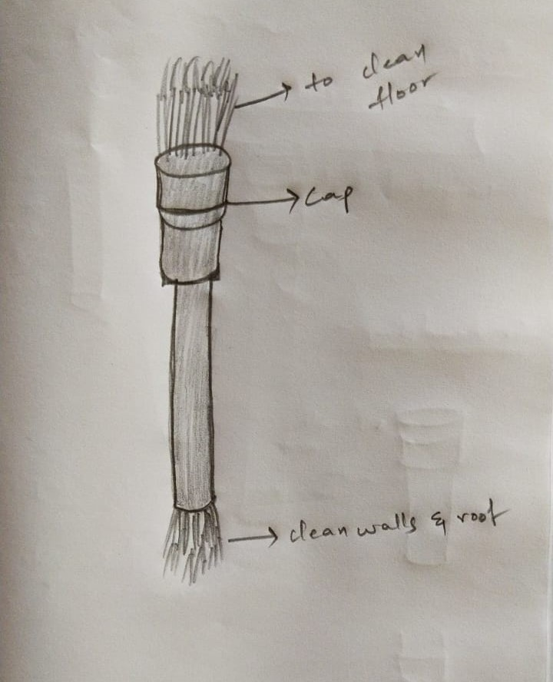**Description with hand sketches :**

In this concept mop stick is having a cylindrical handle with head part on both sides that is up and down. One side of the stick have a head which is used to clean floor and also have a cap to cover it when it is not used or when other side is in use. While at the other side the head is used for cleaning surfaces at height like walls and roof. So, this concept satisfies our need statement and function structure that is dust cleaner with multiple functionalities, here one functionality is to clean floor and other is to clean surfaces at height.

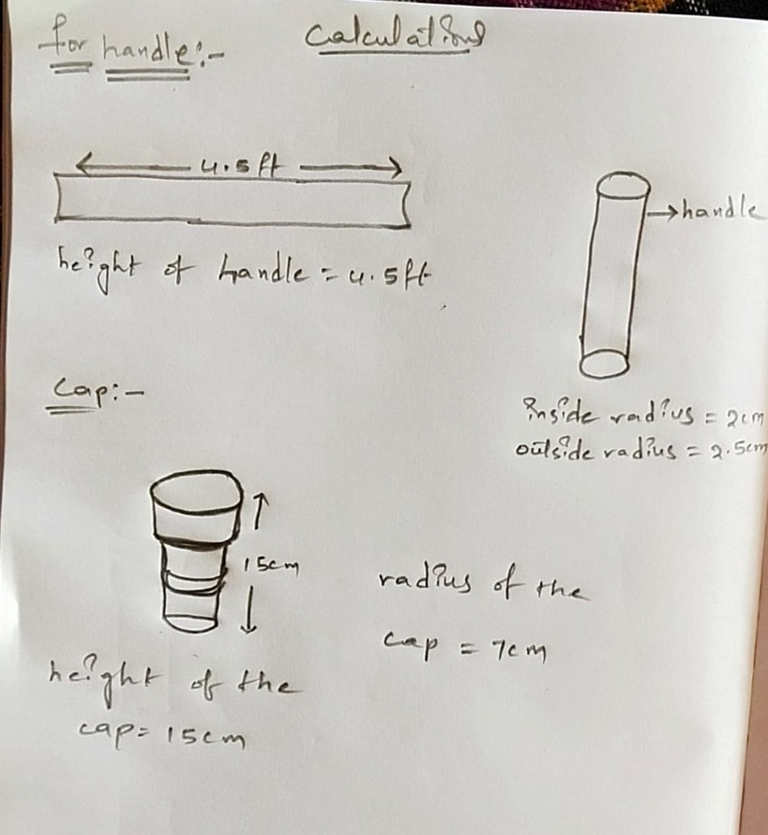**Calculations/Sizing :**

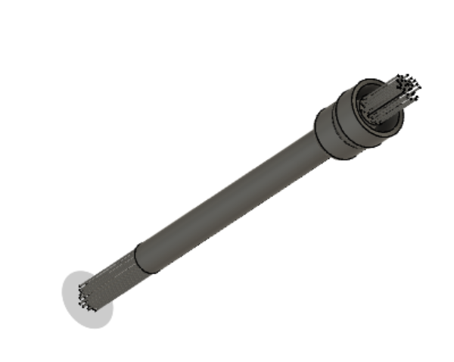**CAD model :**

**3.2 Concept 2 by 406 :**

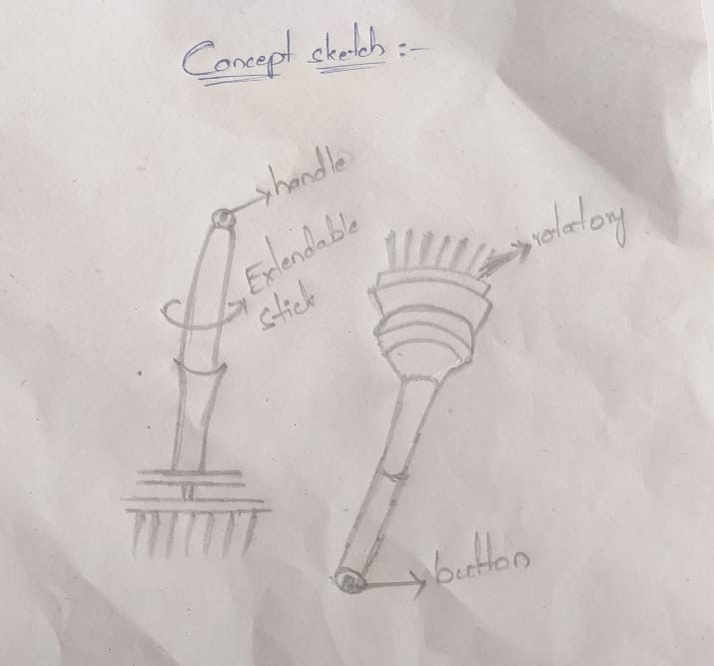**Description with hand sketches :**

In this concept the mop stick is having a cylindrical handle which is height adjustable. It means, according to the surface we clean height can be adjusted. To clean surfaces at height, handle height can be extended and to clean floor the handle height can be reduced. The head is connected to a rotatory motor which can be switched on just by switching on button present at top of handle then the head starts rotating and clean the surfaces. By this concept human effort is reduced and with adjustable height we can clean different surfaces.

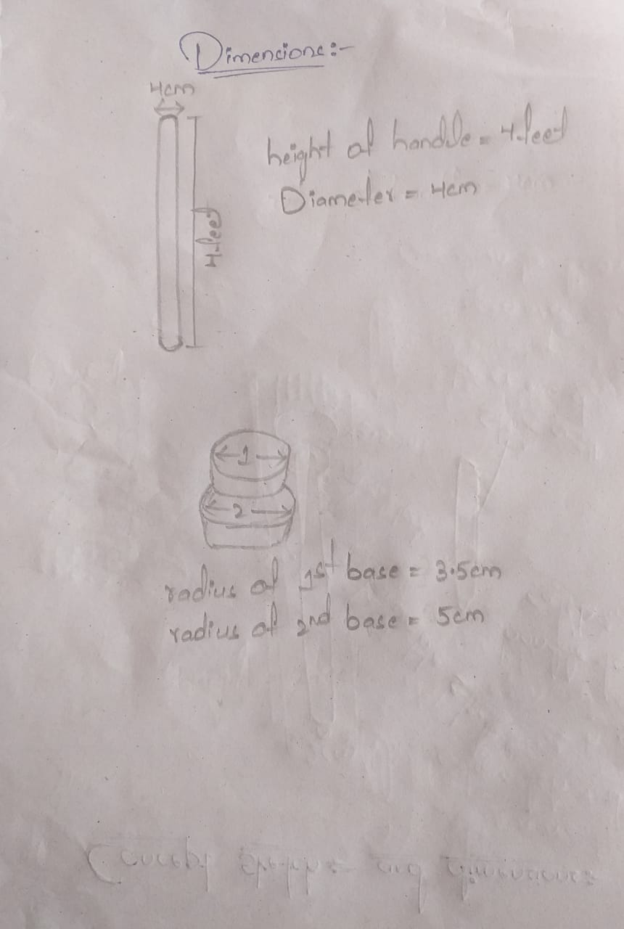**Calculations/Sizing :**

**CAD model :**

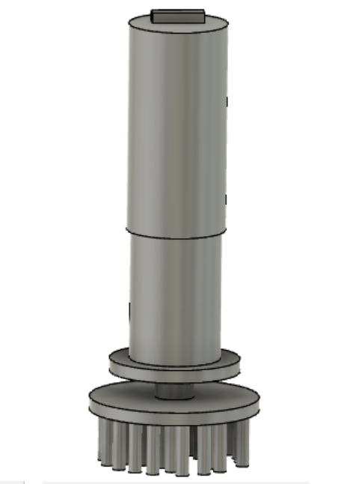

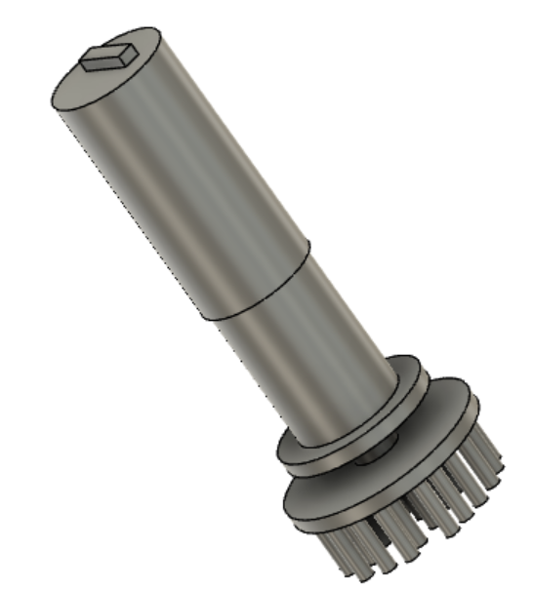

**3.3 Concept 3 by 408 :**

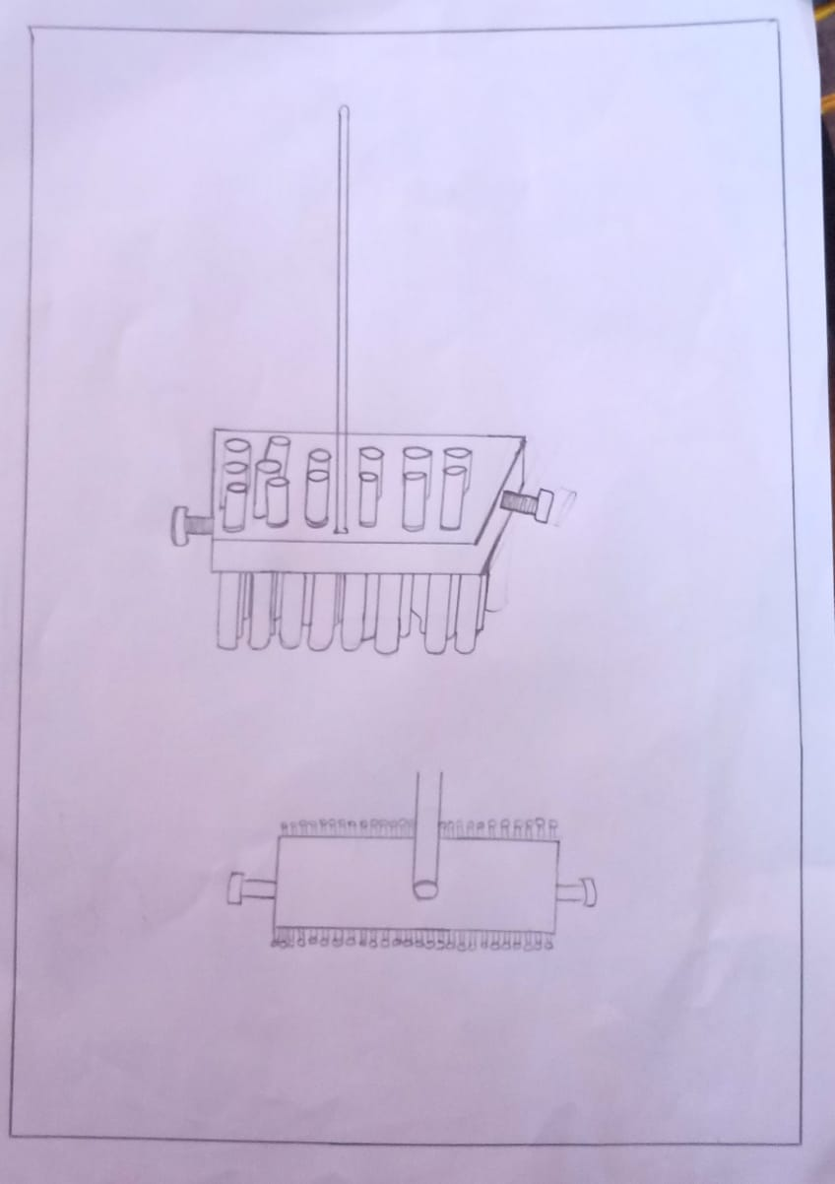**Description with hand sketches :**

In this concept the mop stick is having a cylindrical handle with a rectangular shaped head with cleaning cloth/yarn on top and bottom side of head, with one side of head is used to clean floor and the other side is to clean surface at height or we can use it in other way that is, one side can be used to clean wet surfaces and the other side to clean dry surfaces. The head have two screws on right and left corners which helps to attach head with handle. When the screws are removed the head can be rotated to other side and used again for cleaning.

**Calculations /Sizing :**

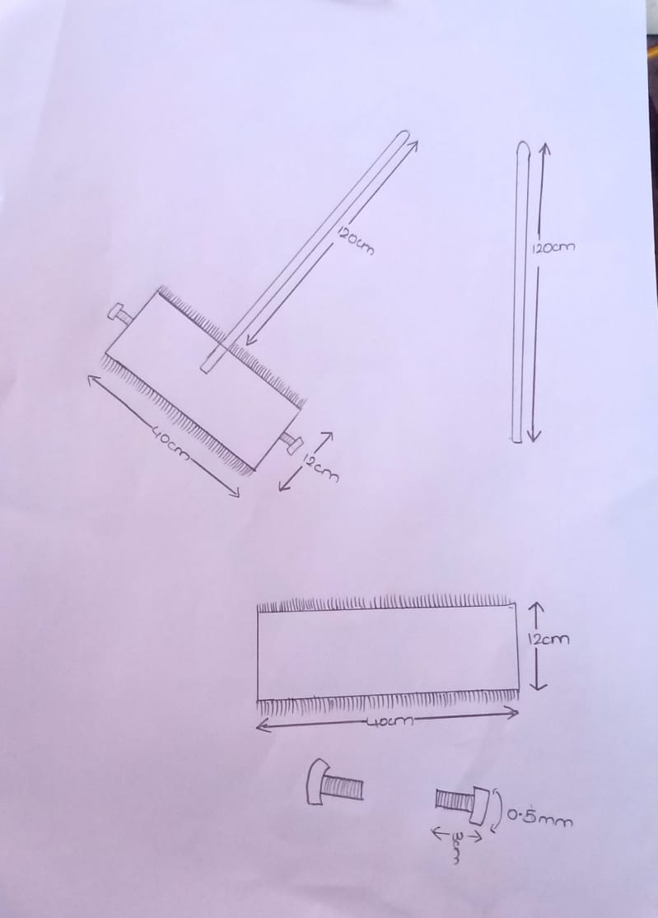

**CAD model :**

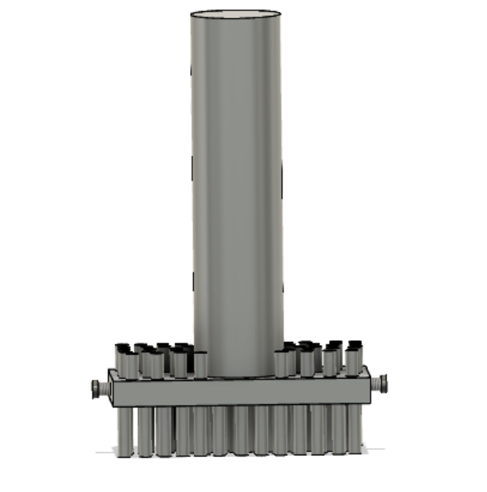

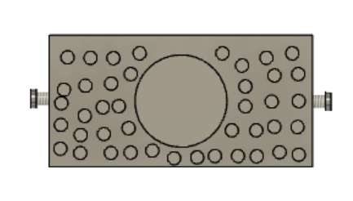

**3.4 Concept 4 by 450 :**

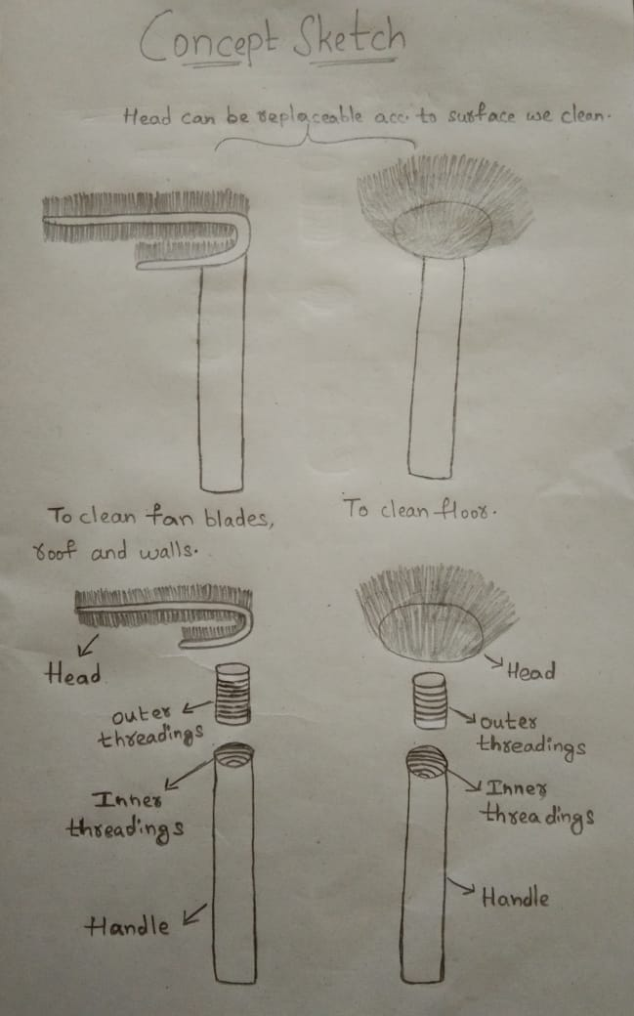**Description and hand sketches :**

In this concept the head can be replaceable according to the surface we clean. One head is hollow C-shaped with cloth/yarn on top and bottom of head which helps to clean fan blades (by placing blades in between the space of C-shape and move to and fro), roof and walls. While the other head is hollow cylindrical shaped with yarn on upper side used to clean floor.

The handle is hollow cylindrical shaped is made with transparent plastic material, which helps to add sanitary liquid into handle which flows into hollow head part and makes cleaning effective.

The head have threading at outer side and the handle have threading at inner side. So that, they can be removed are attached whenever it is necessary.

**Calculations/Sizing :**

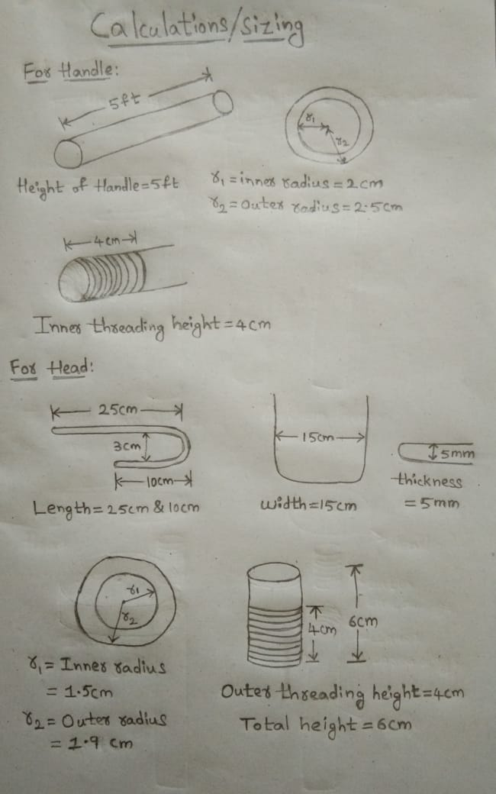

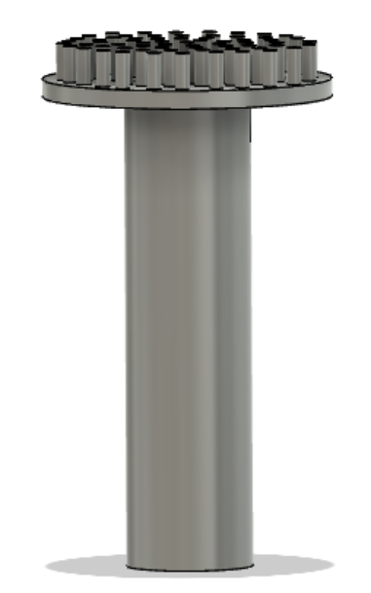**CAD model :**

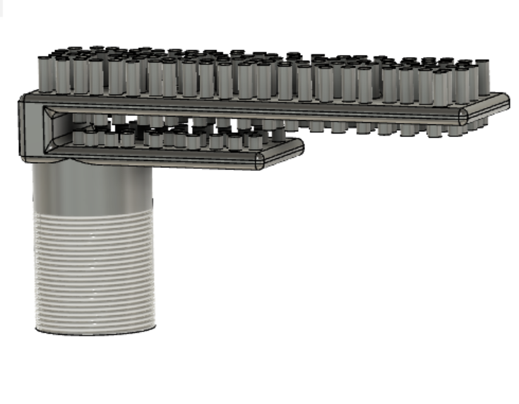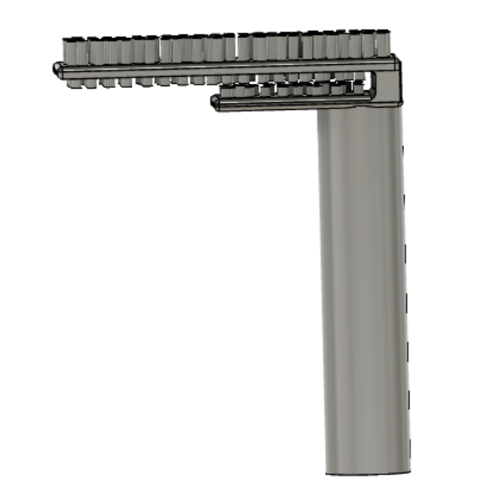

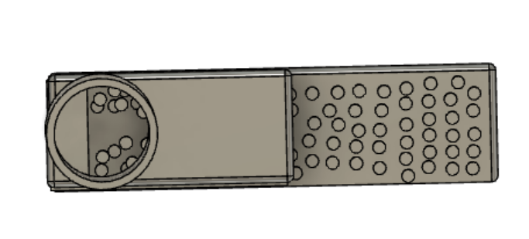

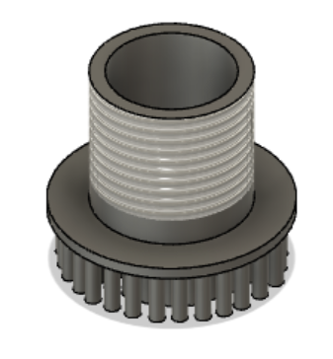

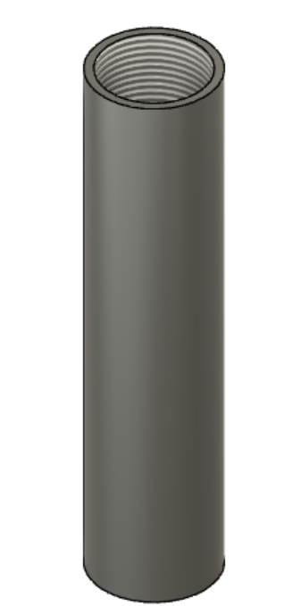

**3.5 Concept evaluation matrix :**

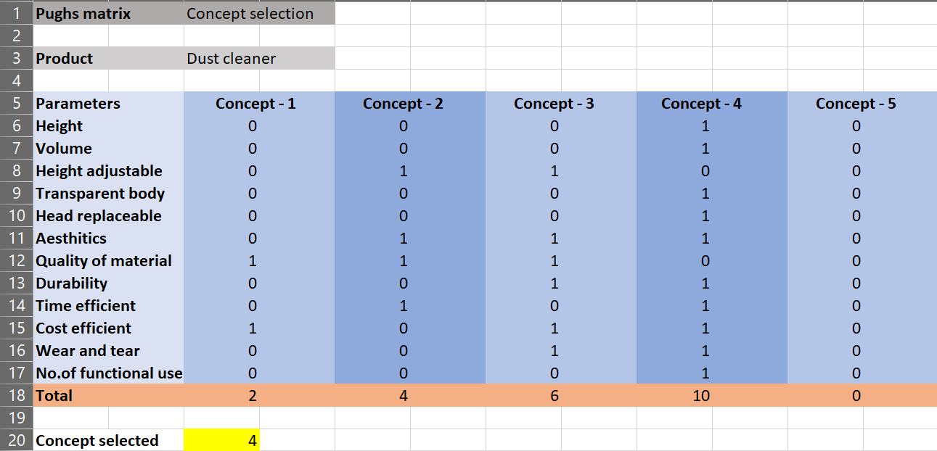

The rating is done by considering concept 5 as DATUM.

The evaluation of concepts are done under these 12 parameters : they are height, volume, height adjustable, transparent body, head replaceable, aesthetics, quality of material, durability, time efficient, cost efficient, wear and tear, no. of functional use.

Among all the four concepts, concept 4 have scored highest. So, concept 4 is selected.

**4 . Recommended Concept**

**The final concept selected is concept number : 4**



The need statement is to design a dust cleaner for office use with multiple functionalities and is time and cost effective.

The concept selected is fulfilling the need statement and function structure. Because, in this concept head is hollow and is replaceable according to the surface we clean, and the handle is hollow cylinder shape made with transparent plastic in which we can add sanitary liquid further flows into head and makes cleaning effective.

The product is approximately 200 rupees which is less cost when compared to other products in market and is multifunctional and time effective for cleaning which makes it more value for money and easy to recommend.

**Appendix 1 – GANTT chart**

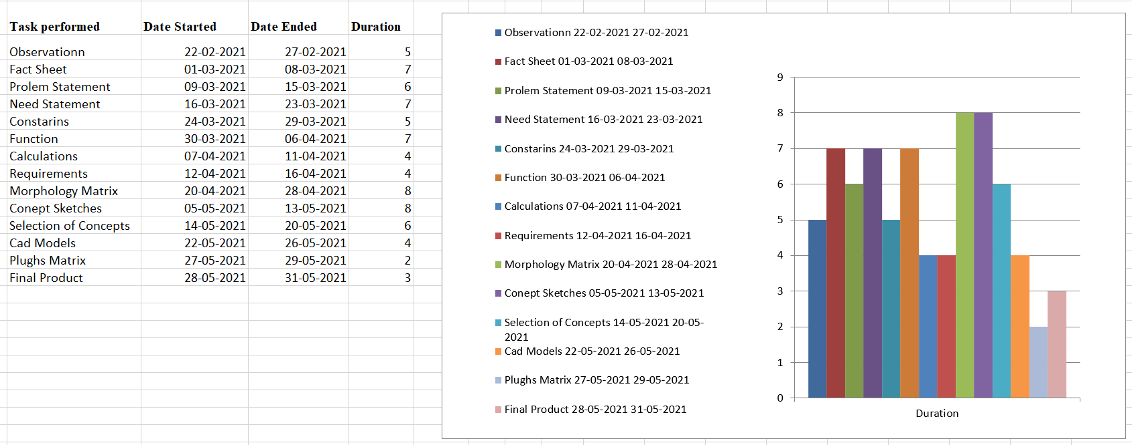

**Appendix – 2**

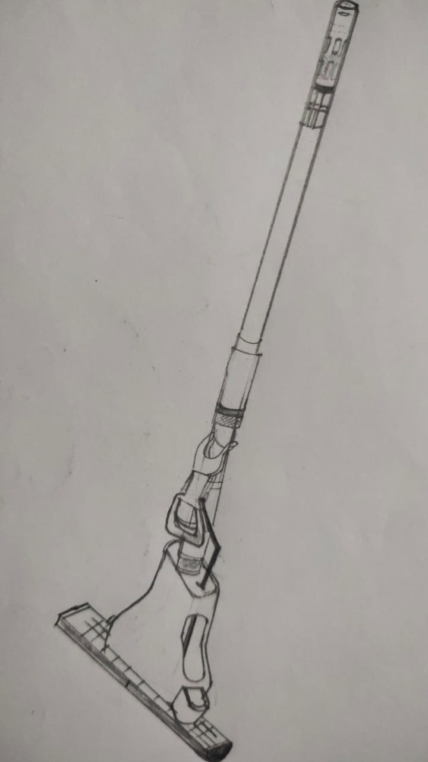**Ideas generated in conceptual design state**

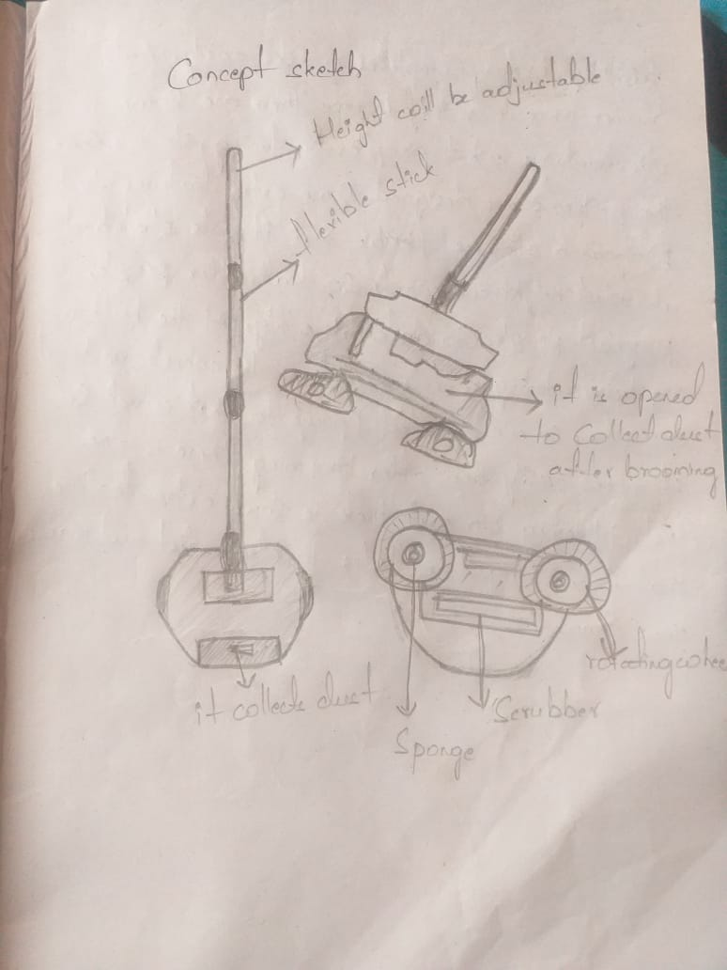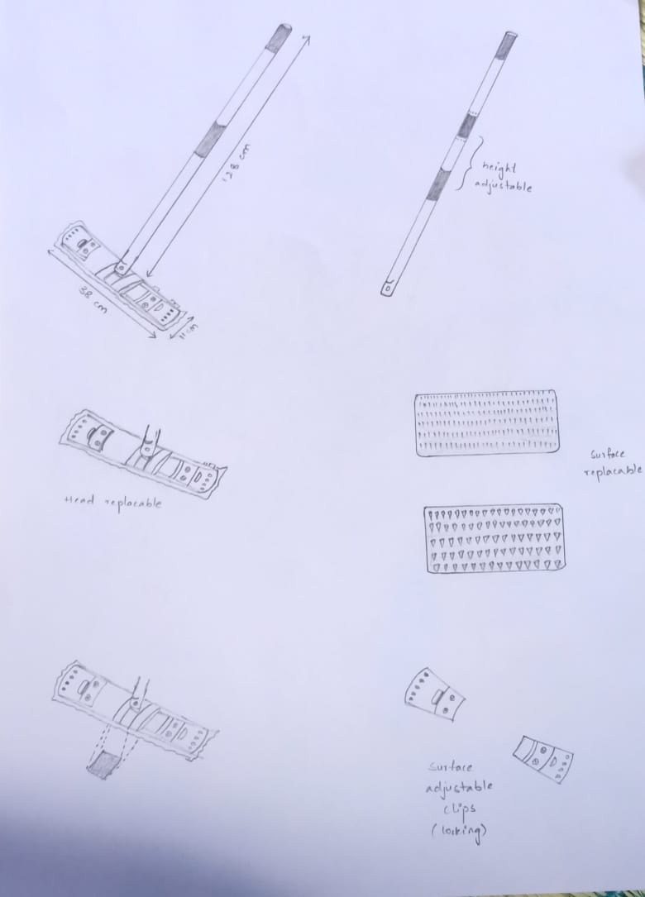****

****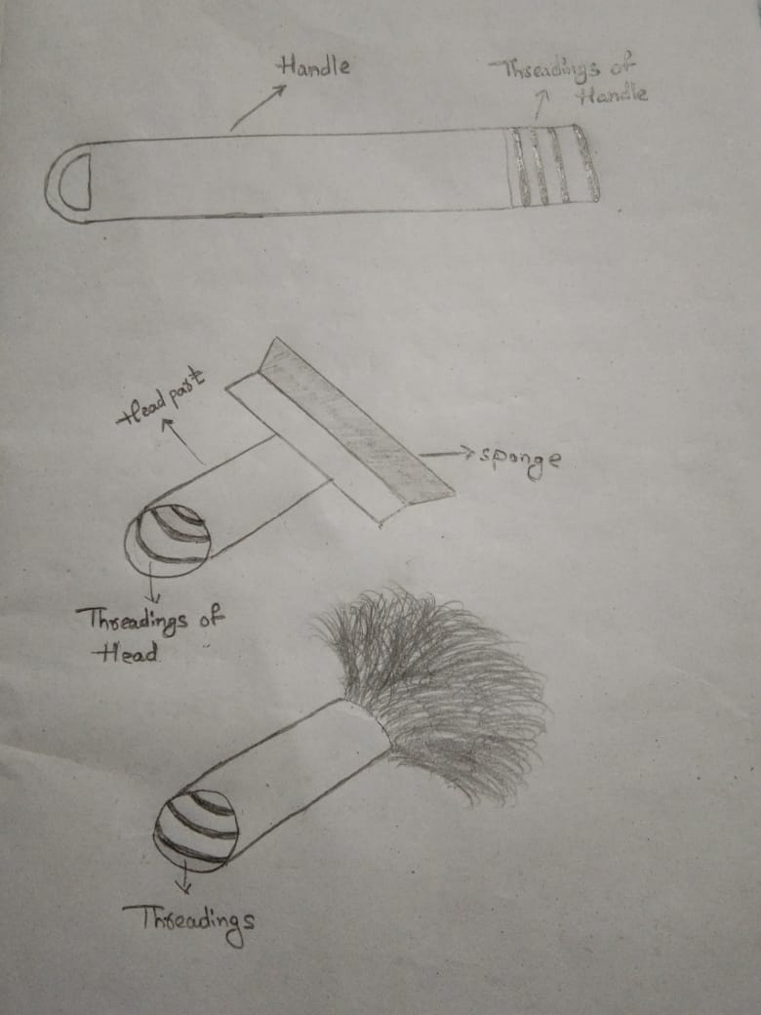

**Appendix 3 – Patent search**

Multi-purpose mop apparatus and method of use :

Application no. : 13766360

Application date : 13.02.2013

Applicants : Minh T. Dinh  
Inventors : Minh T. Dinh

Abstract :

A multi-purpose mop apparatus includes a mop having a mop handle and a cleaning attachment removably mounted thereon, the mop handle further comprising a base and a grip installed thereon for manipulating the mop during use. The cleaning attachment may be a mop material cinched onto the base of the mop handle using a drawstring or may be a squeegee strapped thereto. A removable extension handle may be pivotally installed on the mop handle and configured for use in multiple configurations and modes.

CLEANING TOOL WITH REMOVABLE CLEANING SHEETS :

Publication Number : WO/1999/063879

Publication Date : 16.12.1999

Applicants : McKAY, William, D. [US]/[US]

Inventors : McKAY, William, D.

Abstract : A mop (10) for cleaning a floor includes a handle (12) for a user to grip the mop (10) and a mop head (20) which is interconnected with the handle (12). The mop head (20) has a lower surface (24) and an upper surface (22), each of which have a side to side width and a back to front length. Multiple cleaning sheets (46) are each removably supported on the lower surface (22) in a stacked configuration. Each of the sheets (46) has an outerward face (60) for cleaning and an opposed inward face (62). The outward face (60) of each of the sheets (46) is configured for contacting and cleaning the floor causing them to be soiled. When the outward face (60) of the outermost sheet becomes soiled, that sheet may be peeled away to expose a non-soiled sheet. In some embodiments, the mop head (20) and the handle (12) are pivotally interconnected.